RF

**Que1:**



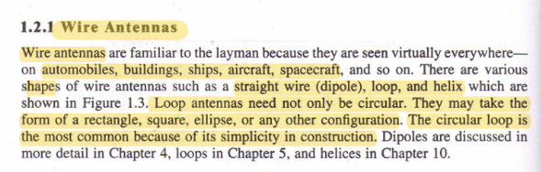

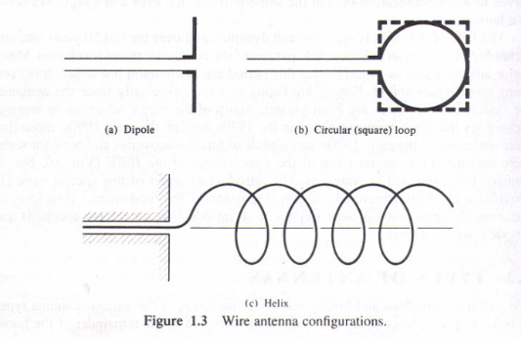

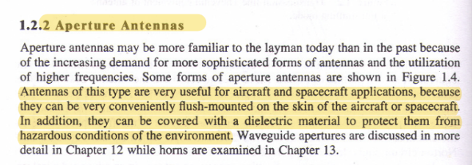

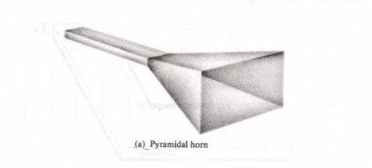

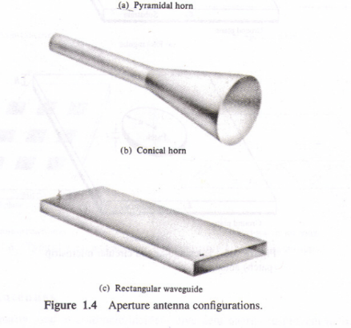

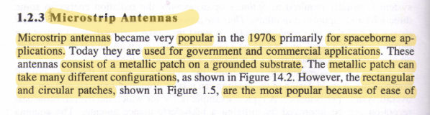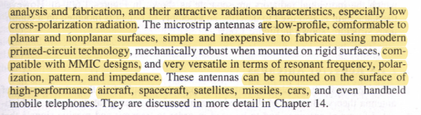

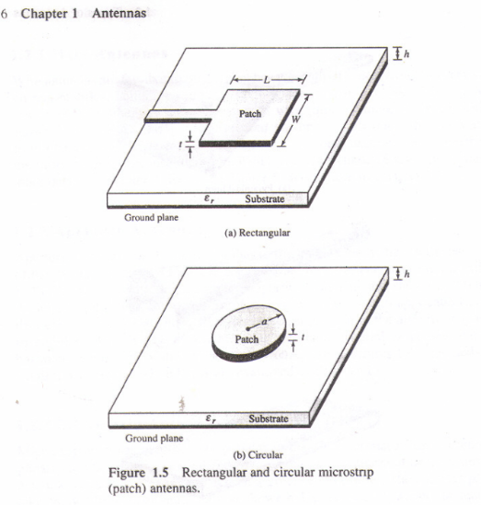

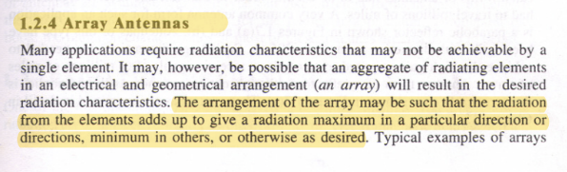

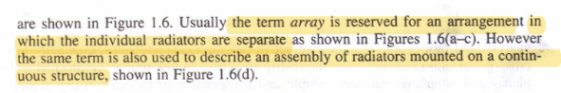

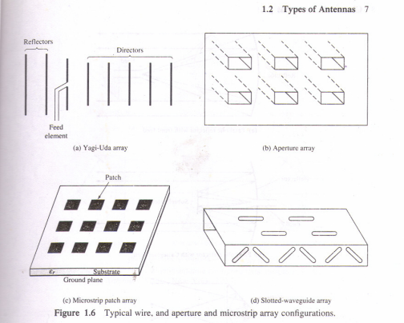

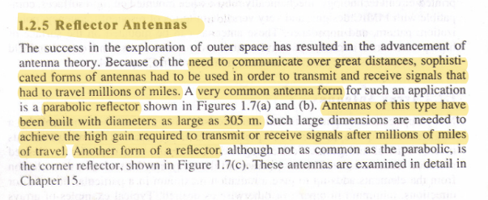

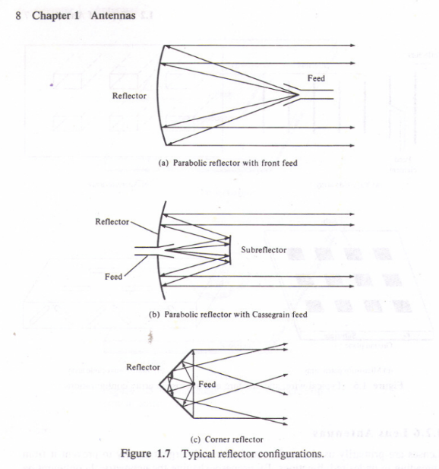

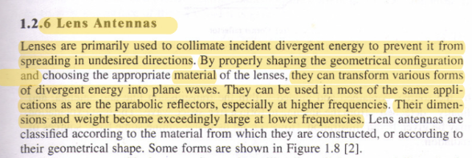

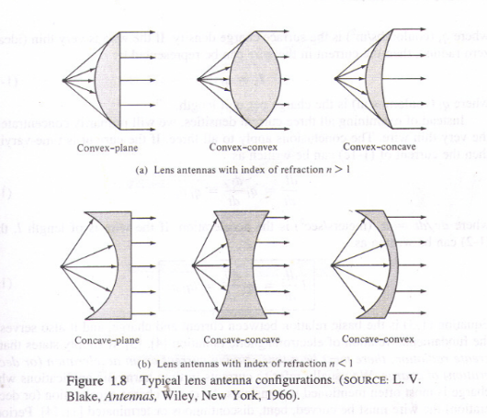



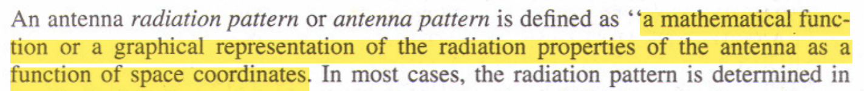

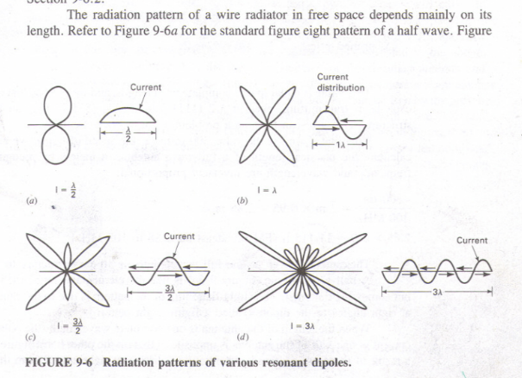

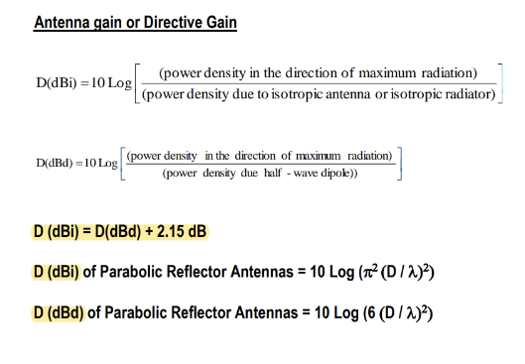

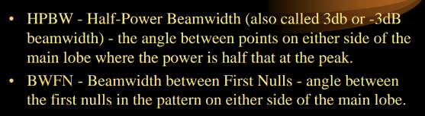

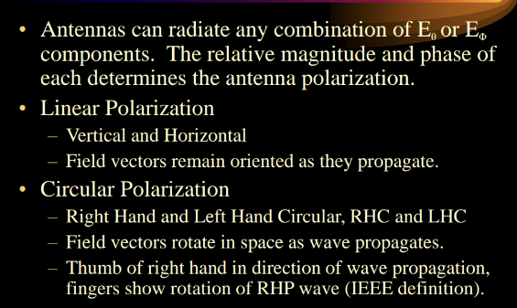

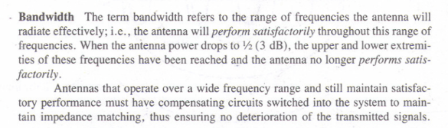

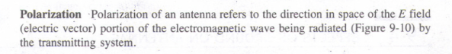

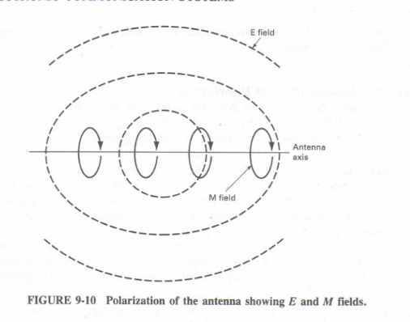

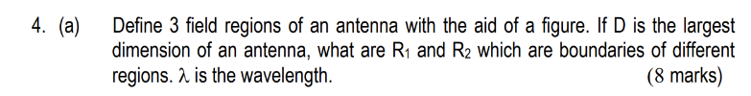



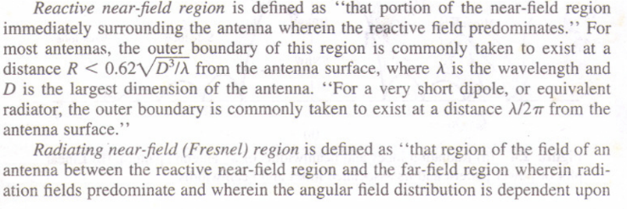

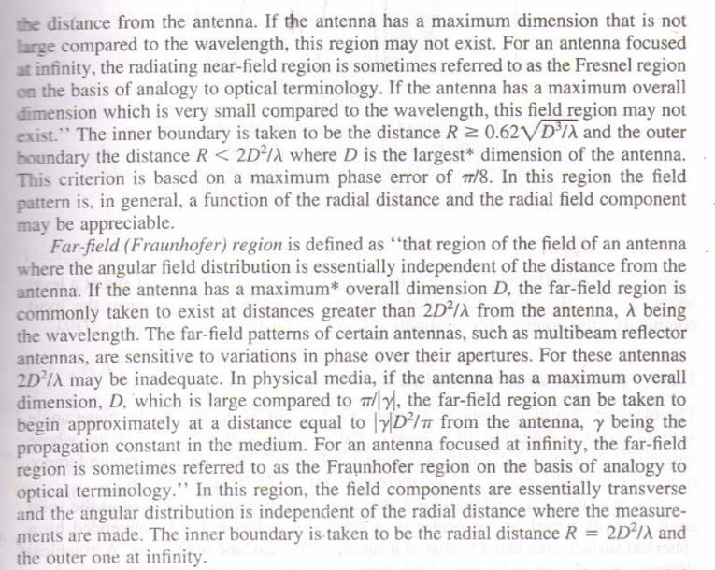

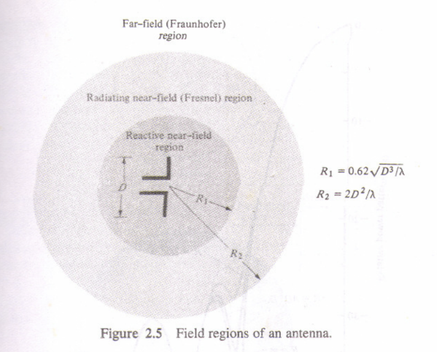

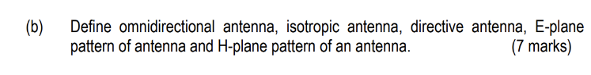

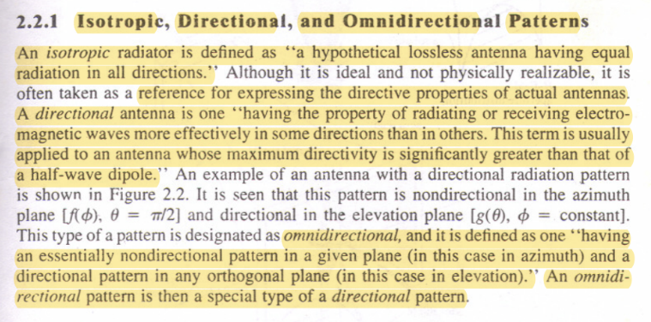

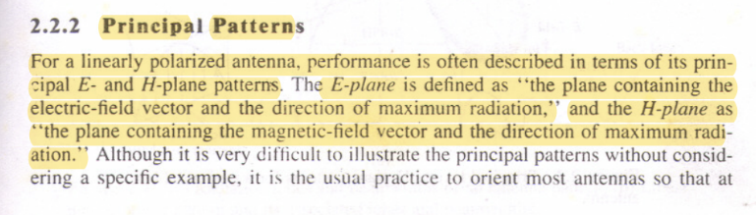

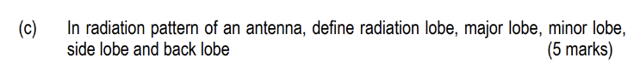

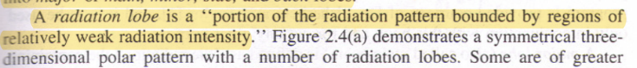



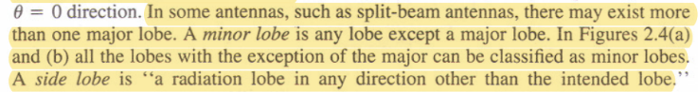



**Que 2:**



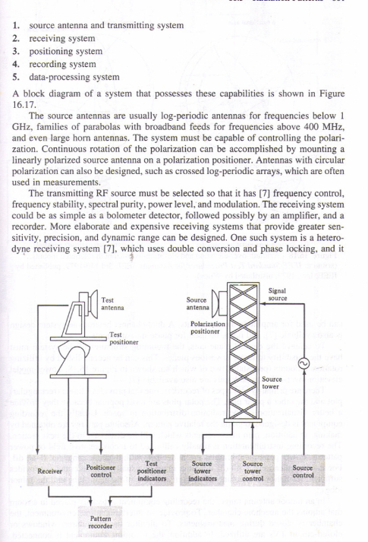

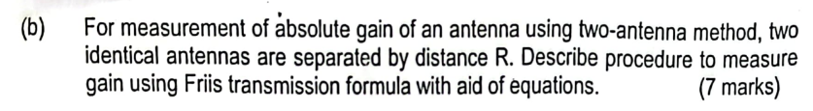

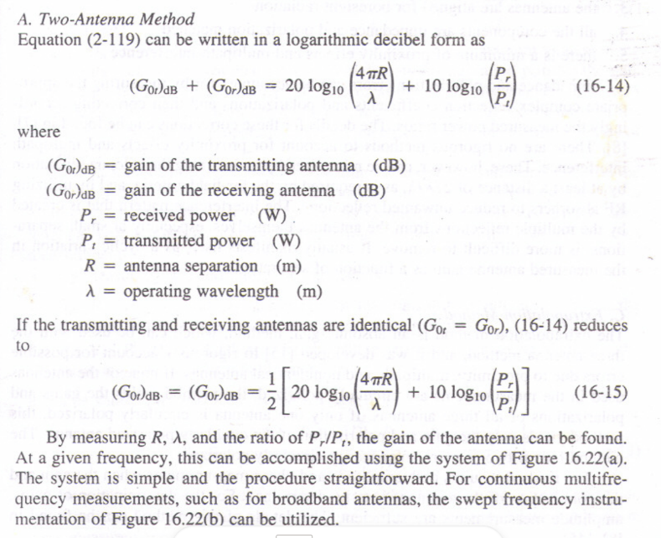

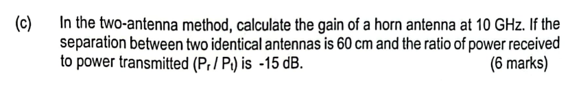

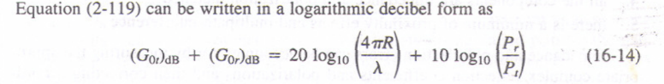

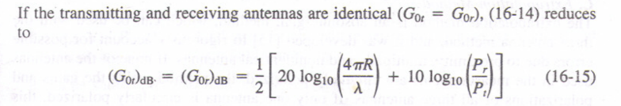

Put values in one of the two equations, since don’t know what is horn antenna.

Que 3 :

a)

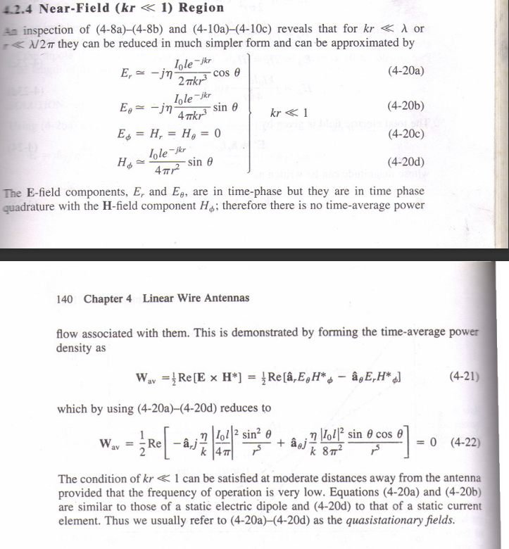

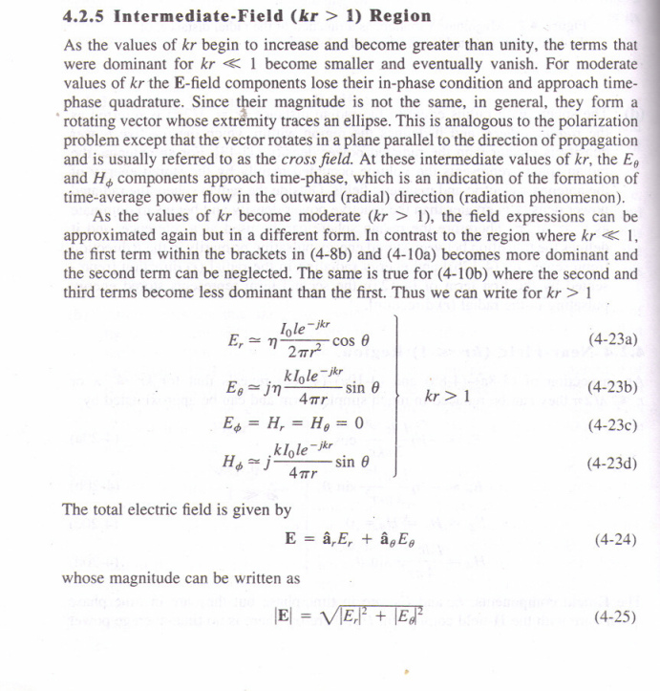

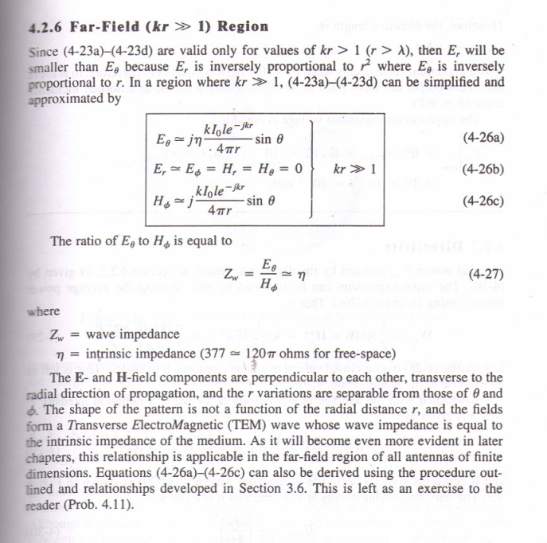

b)

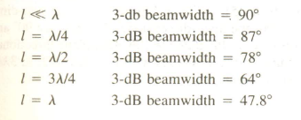

c)

The resonant antennas are like resonant transmission lines. The dipole antennas are example of this antenna type. They are open ended at far end with resonant length. The term resonant length refers to multiple of quarter wavelength. It is placed at a point on the transmission line where it delivers low impedance.

The Non-resonant antennas are like nonresonant transmission lines. Nonresonant transmission lines do not have standing waves. Hence they do not have any reflected waves and they have only forward travelling waves.

From the radiation patterns of both, the difference between resonant antenna and nonresonant antenna is as follows.  
➨Nonresonant antennas are uni-directional and resonant antennas are bi-directional.  
➨In nonresonant antennas only forward waves exist and in resonant antennas both forward and reflected waves exist.

The gain of hertzian dipole is 1.76 dBi, 2.15dBi for half-wave dipole, 8.51 Dbi for 8-wave dipole

d)

When analyzing antennas, certain assumptions are made about the current distribution along the length of the antenna. Here are the assumed current distributions and radiation patterns for the infinitesimal antenna, half-wave dipole, and eight-wave dipole:

Infinitesimal Antenna:

Assumed Current Distribution: The infinitesimal antenna is a theoretical concept with zero dimensions. For analysis, a uniform current distribution is often assumed along its length.

Radiation Pattern: The radiation pattern is considered isotropic, meaning it radiates equally in all directions. In reality, an infinitesimal antenna doesn't exist physically, but it is a useful theoretical construct for understanding basic antenna principles.

Half-Wave Dipole:

Assumed Current Distribution: A sinusoidal current distribution is commonly assumed for a half-wave dipole. This means that the current along the antenna's length varies sinusoidally, reaching zero at the ends and maximum at the center.

Radiation Pattern: The radiation pattern of a half-wave dipole is bi-directional, resembling a figure-eight shape. It has lobes in two opposite directions perpendicular to the antenna, and nulls along the axis of the antenna.

Eight-Wave Dipole:

Assumed Current Distribution: Assuming an eight-wave dipole refers to a dipole that is eight wavelengths long, the current distribution would still be sinusoidal, but with more cycles along the length of the antenna compared to a half-wave dipole.

Radiation Pattern: The radiation pattern becomes more directional with more lobes and nulls as the antenna becomes longer. The lobes will be narrower, and the antenna will exhibit higher directivity compared to a shorter dipole.

It's important to note that these assumed current distributions and radiation patterns provide a simplified understanding for analytical purposes. In practice, real-world antennas may deviate from these idealized models due to factors like the presence of nearby objects, ground effects, and imperfections in the antenna structure. Measurements and simulations are often used to characterize the actual performance of antennas in specific environments.

**Que 4:**



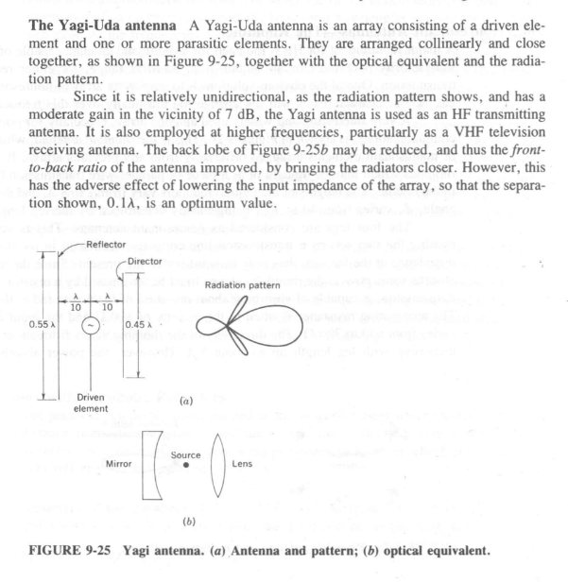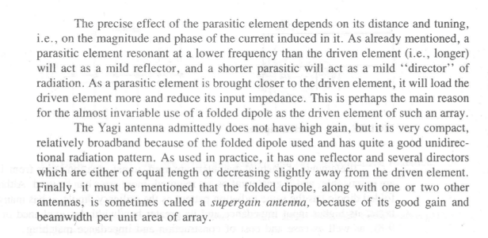

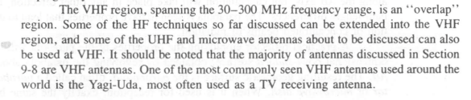

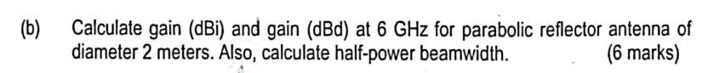

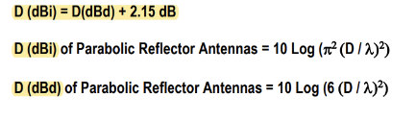

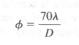

Half power beamwidth:



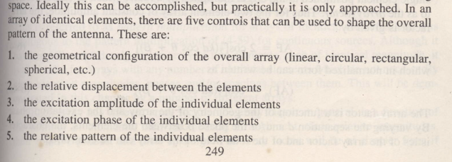



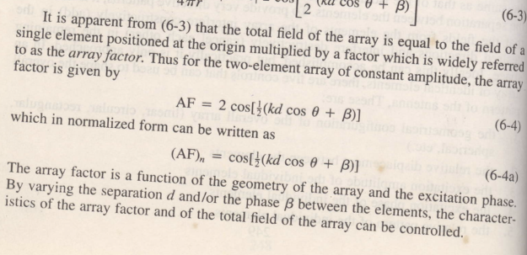

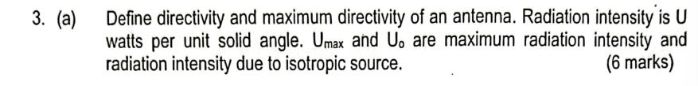

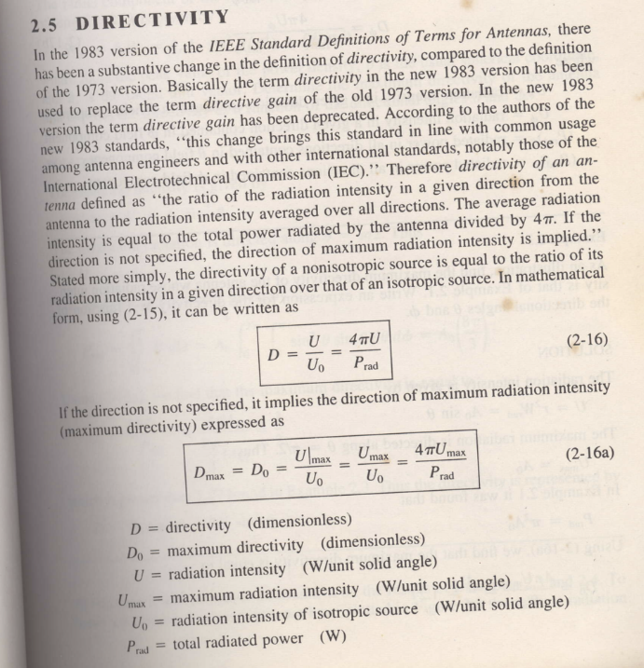

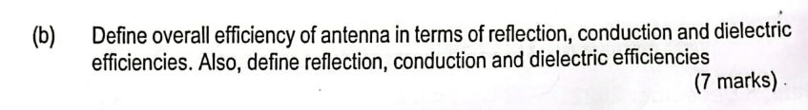

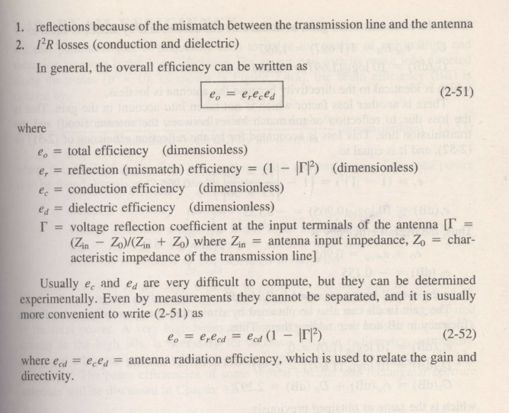

Endsem 3 c) Space wave No question che. Not in syllabus